**Mechatronics Assignment – Introduction to Simulink**

**Simulink model 2nd order system based on controlling the velocity of a motor**

1. **Model with Step Response**

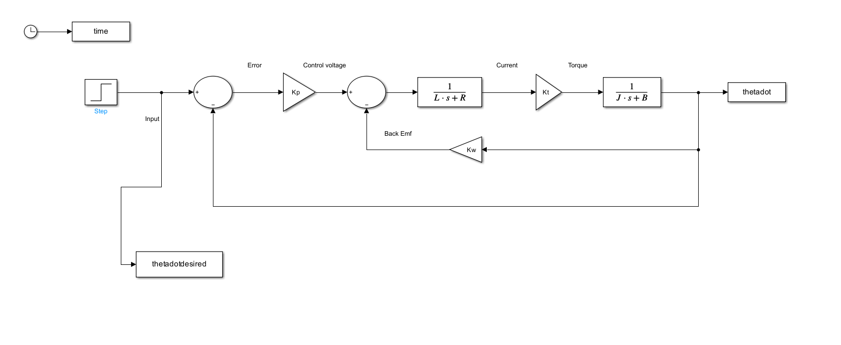

**Kp = 1**

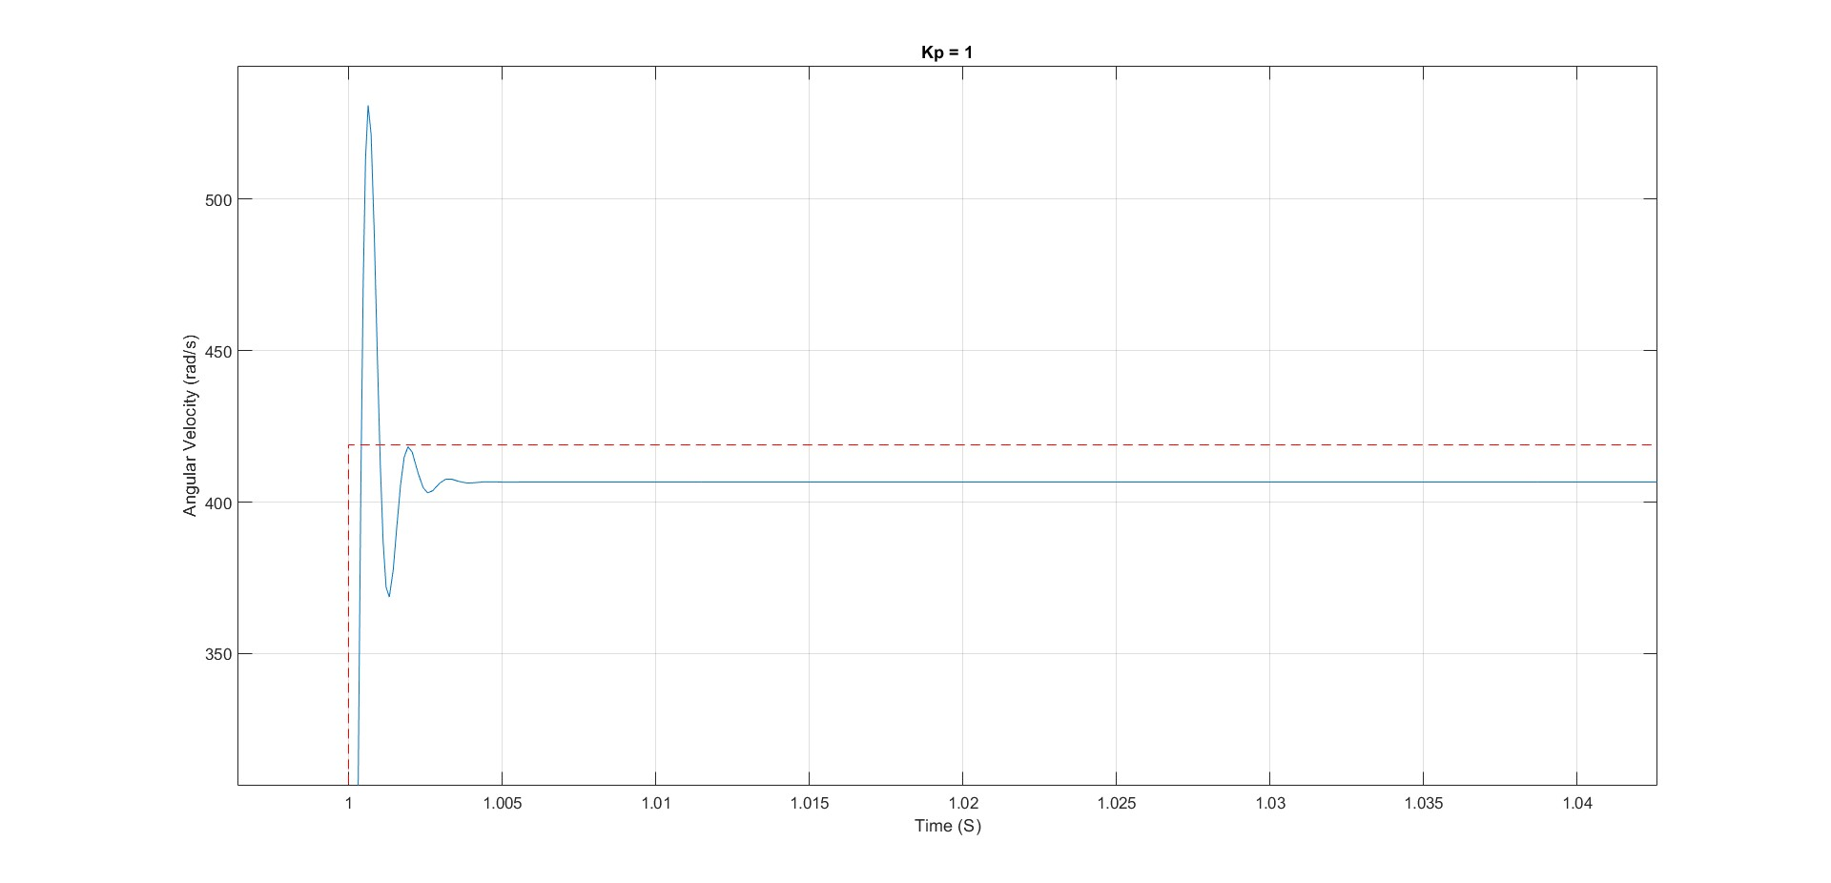

**Kp = 2**

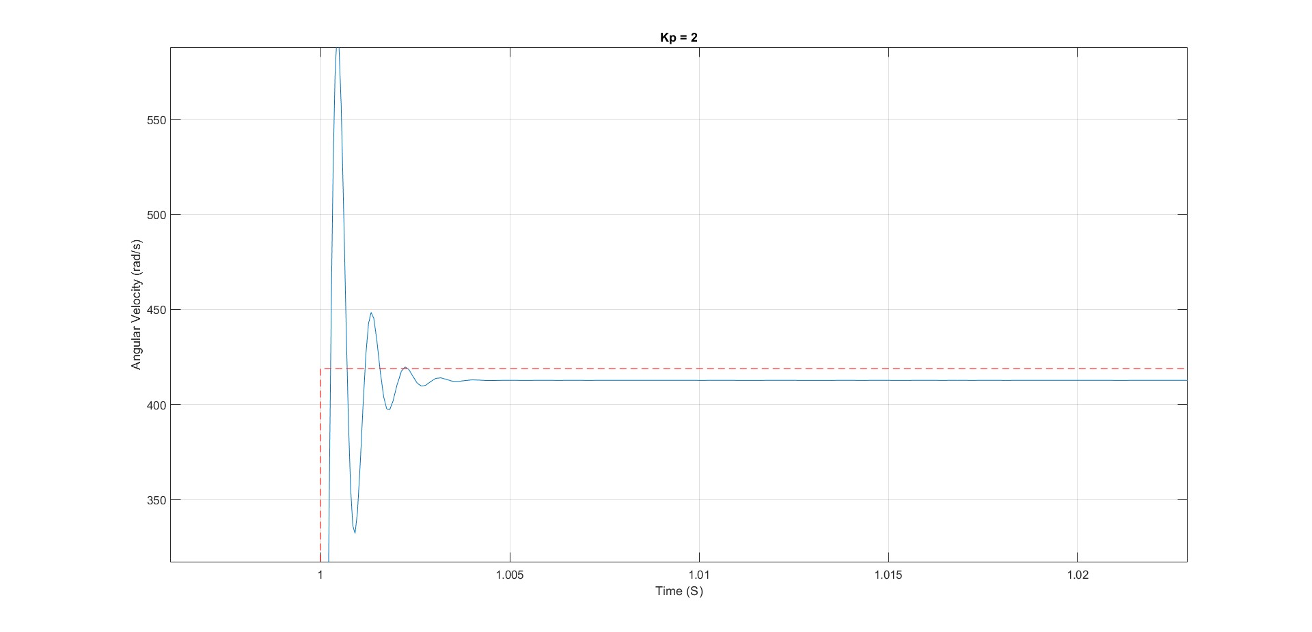

**Kp = 5**

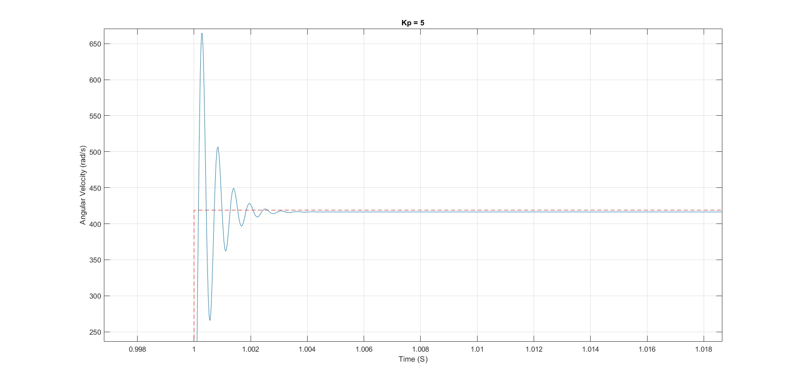

**Kp = 10**

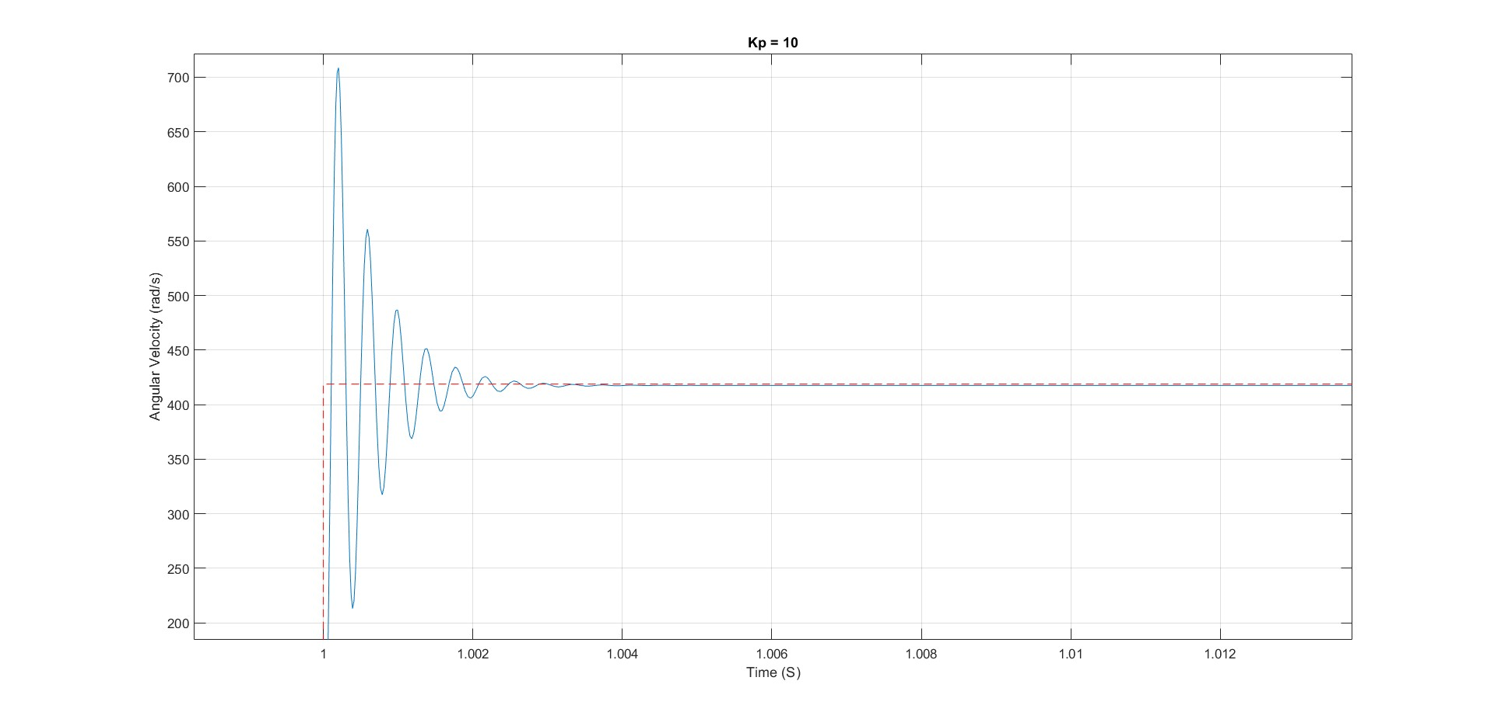

1. **Model with Sinusoidal Response**

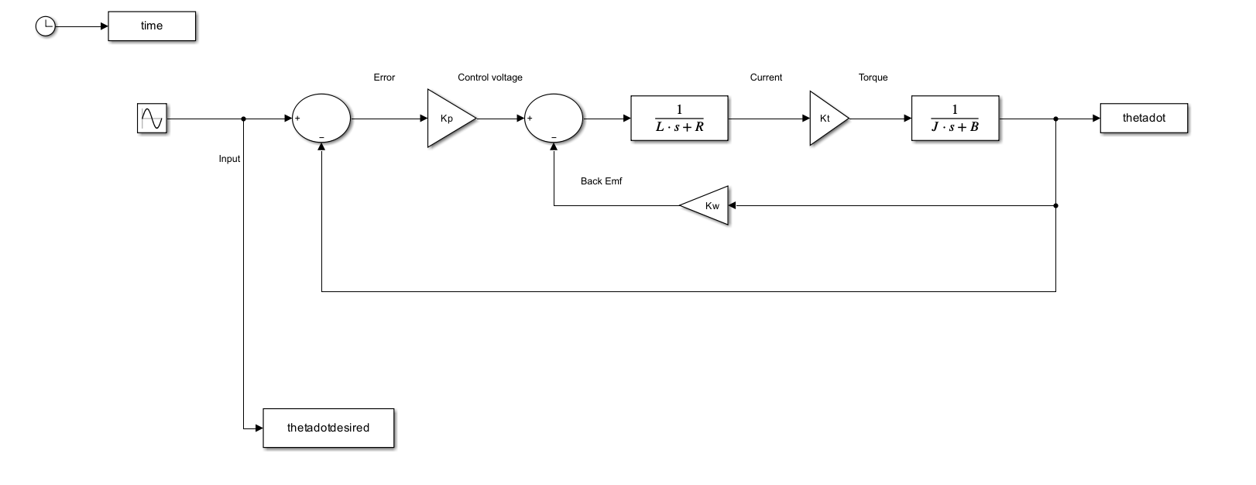

**Kp = 1**

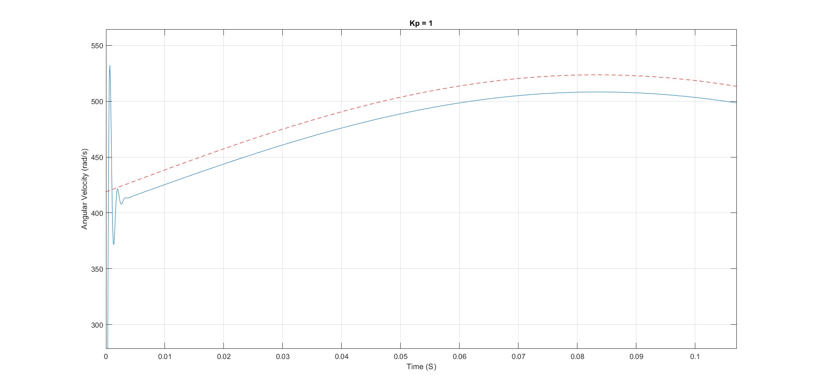

**Kp = 2**

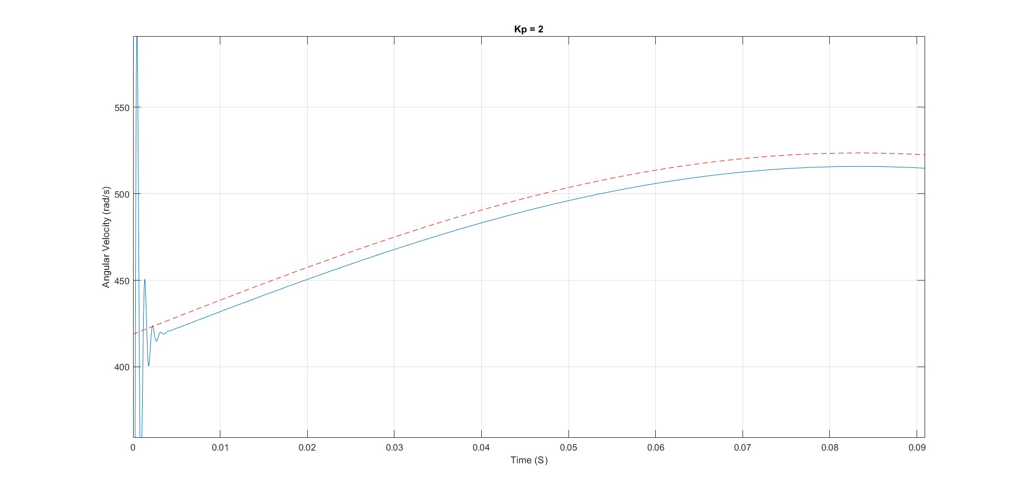

**Kp = 5**

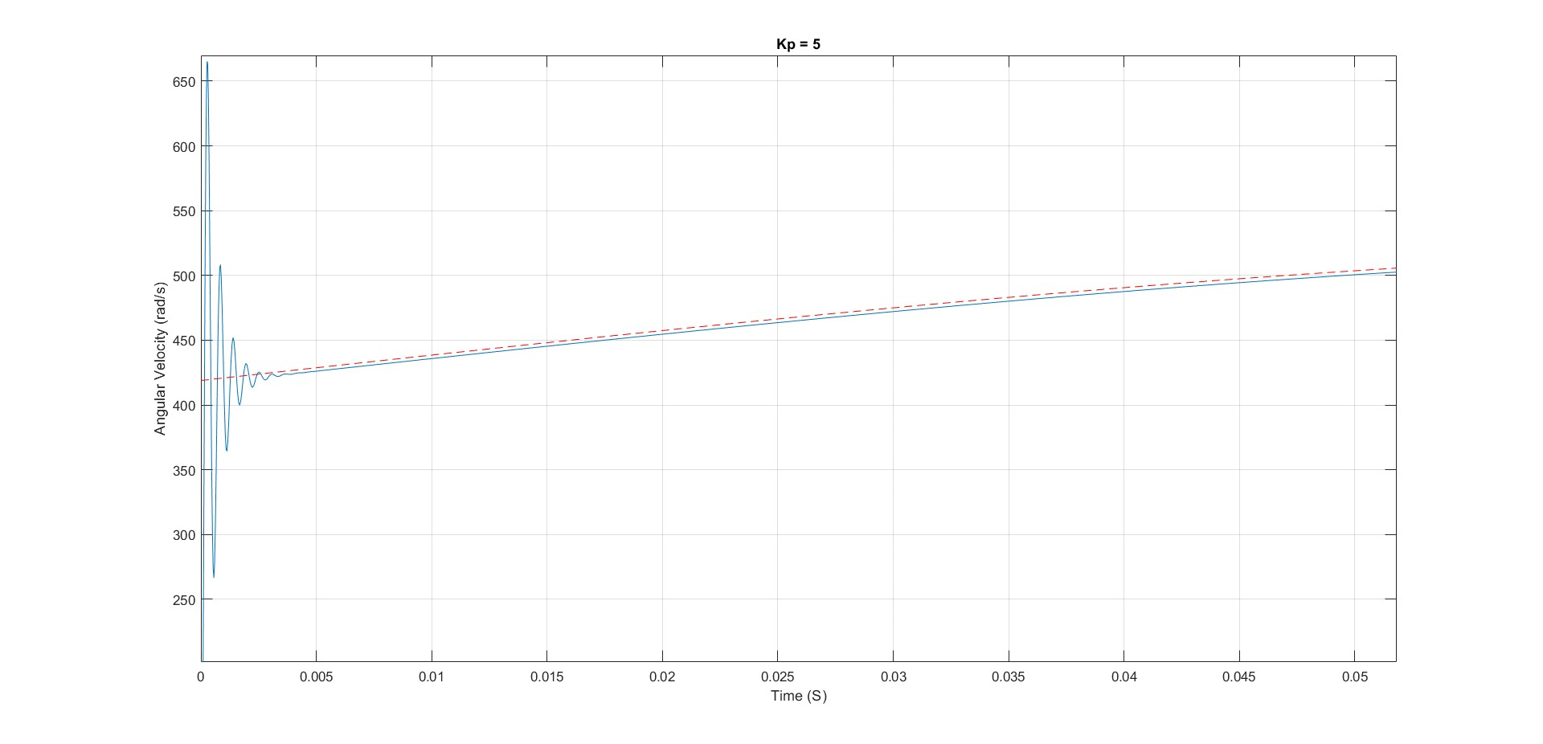

**Kp = 10**

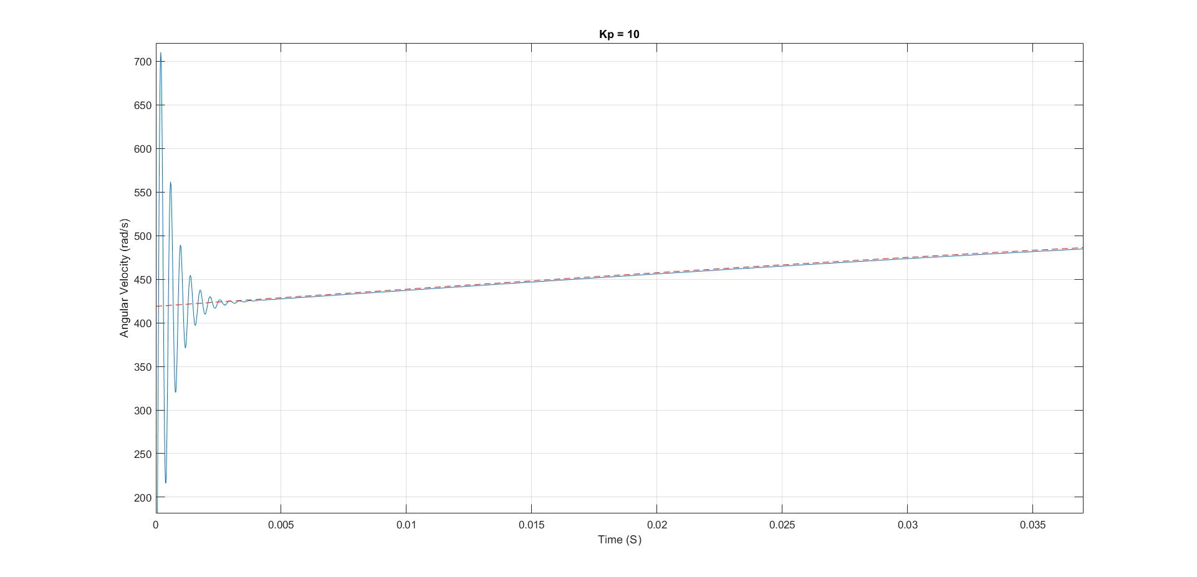

**The model with both Kp and Ki and has no overshoot**

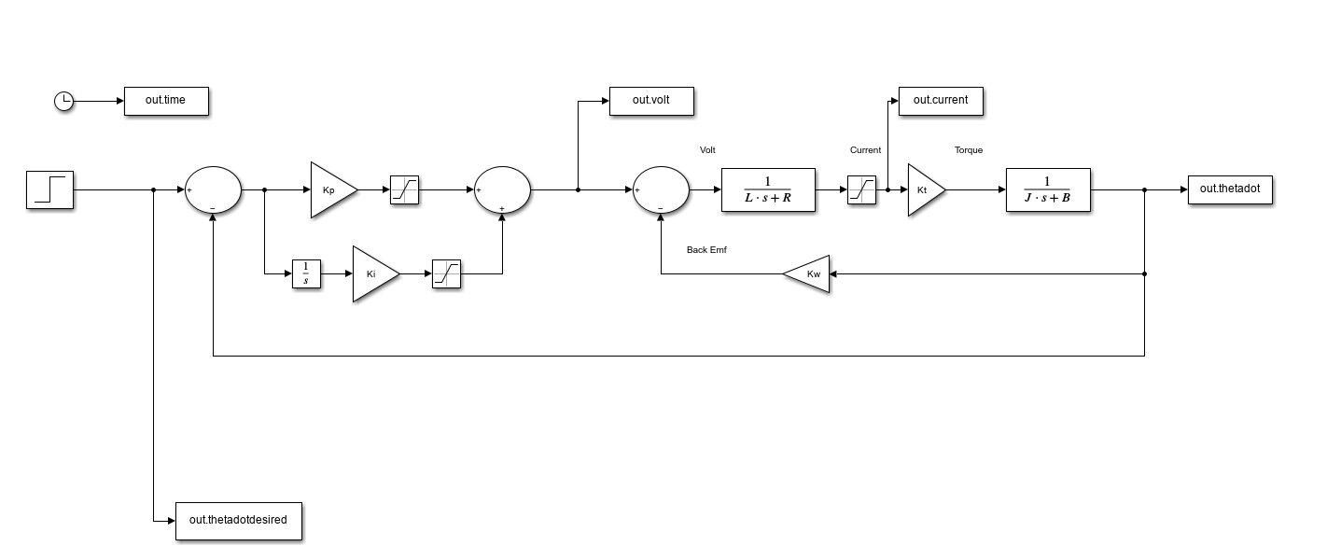

And the best **step response** for **Kp = 1** and **Ki = 3**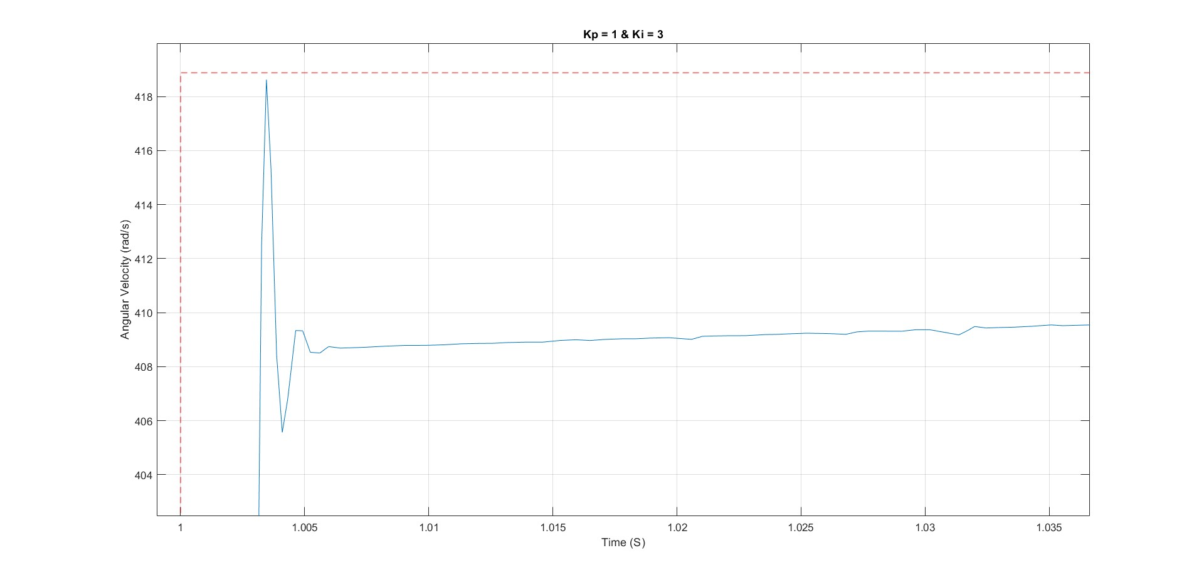

Best **sinusoidal response** for **Kp =1** and **Ki = 4**



